An Epigenetic Engram: Linking RNA to Aplysia Sensitization
-----
Scientists have been searching for centuries hoping to find the elusive engram, or physical trace left on the brain by memory. Recently, researchers discovered that neuronal sensitization (perhaps the simplest form of memory) can be transferred among Aplysia (sea slugs) via RNA. These results implicate RNA as part of the engram for Aplysia sensitization and have important consequences for the study of memory.

Memory is a concept central to human experience, and yet neuroscientists still find the engram, or neurological changes linked to memory, intangible. Memory is commonly understood as an encoded response to a stimulus, and ranges from simple neuronal sensitization to complex linguistic human memory. A prominent hypothesis is that memory is stored in neural circuits, and that the formation of new memories alters these circuits. Circuits can be altered through activity-dependent mechanisms such as synaptic long-term potentiation (LTP) or depression (LTD), providing a potential molecular model for how memory is stored at the synapse (Lynch, 2004). LTP is particularly intriguing because it relies upon N-Methyl-D-aspartic acid (NMDA) glutamate receptors in the post-synaptic membrane, which, as coincidence detectors, are only activated in the event of simultaneous binding of glutamate and membrane depolarization.
Long-term memory (LTM) is understood to be linked to modifications in LTP and synaptic connections; however, there is selected evidence to suggest LTM can be stored in neuronal cell bodies. Memory formation in Aplysia is partially dependent upon protein synthesis (Pinsker et al., 1973). Scientists are still trying to elucidate how this protein synthesis modulates memory formation, although it is possible epigenetic modifications may be involved (Zovkic et al., 2013). Once the identity of this protein can be derived, scientists may have a better idea of how the dynamics of the cell body impact synaptic plasticity and the storage of memory.
Previous research has shown that non-coding RNA strands, which may be important in memory formation, can also play a role in epigenetic modifications (Bédécarrats et al., 2018). Specifically, RNA may be linked to a type of modification called DNA methylation, where methyl molecules are added to DNA. This can modulate DNA expression, and when present on the promotor region of a gene, DNA methylation often reduces expression of said gene (Bird, 2002). Based on this information, Dr. David L. Glanzman (UCLA) and colleagues hypothesized in the article entitled “RNA from Trained Aplysia Can Induce an Epigenetic Engram for Long-Term Sensitization in Untrained Aplysia” that part of the engram may be stored in RNA. To test this hypothesis, the authors transferred RNA between Aplysia to examine if memories can be transferred via RNA.
The researchers first trained adult Aplysia californica, sensitizing them to repeated tail shocks. When an organism or cell is sensitized it exhibits a greater response to a given stimuli after repeated exposure, making sensitization a rudimentary but relatively easy-to-study form of memory. The level of sensitization was analyzed by quantifying the siphon-withdrawal reflex (SWR), whereby Aplysia retracted their siphon in response to a shock. Non-sensitized Aplysia were used for the control condition. Next, the researchers removed the pleural-pedal and abdominal ganglia from trained and untrained Aplysia and isolated RNA by homogenizing and precipitating the samples. RNA was injected into the hemocoel (main body cavity) of naïve, untrained Aplysia. This allowed the RNA to perfuse the animal. Some RNA injections also included DNA methyltransferase (DNMT) inhibitor (RG-108) to reveal the role of DNA methylation in RNA-mediated memory. The authors also isolated pleural sensory neurons and small siphon motor neurons, culturing these cells and preforming electrophysiological recordings.
The researchers confirmed that Aplysia were sensitized by noting the enhanced SWR in trained animals after the first training session. After RNA was injected into naïve Aplysia, the researchers tested the SWR in these animals (Figure 1). Naïve Aplysia injected with trained RNA had a significantly higher SWR than those injected with untrained RNA. Only trained RNA resulted in SWR enhancement in naïve Aplysia. When the authors compared the injection of trained RNA without RG-108 into naïve Aplysia to injection with RG-108, they found that only the RNA solution lacking RG-108 had SWR enhancement. Upon examination of the in vitro impact of RNA on neuron excitability, the authors found that RNA from trained Aplysia resulted in increased sensory (but not motor) neuronal excitability. Interestingly, the authors noticed that the trained RNA may modulate sensory neuronal excitability using the same current that is altered by electric shock delivery to the Aplysia body.
In summary, the authors found that injecting RNA from sensitized Aplysia into naïve Aplysia induces behavior indicative of sensitization. Because the inhibition of DNA methylation blocks RNA-induced sensitization, DNA methylation is likely required for the RNA to modulate Aplysia sensitization. Additionally, the form of sensitization used in this study produces RNA that only alters sensory neuron excitability (indicating that sensory neurons may be altered by this type of sensitization, but not motor neurons).
These results are important and prominent because they reveal that, at least in Aplysia, RNA may be an essential component of the engram. Sensitization may increase cellular levels of specific RNA strands that then modulate DNA methylation. DNA methylation (which, as discussed earlier, can modulate gene expression) may alter the expression of certain genes important for a sensitized Aplysia response to a stimulus. Mimicking the epigenetic code of sensitized Aplysia may be sufficient to encode the sensitized training response. Thus, DNA methylation may then be related to the storage of memory and the expression of this memory as sensitization to a stimulus.
Although this study (and much of the news circulating regarding it) implies a link between RNA and complex memory, the results presented do not. Aplysia neuronal sensitization is an incredibly simple and useful model for memory, however, it is a far cry from the complex memory that humans experience. RNA may indeed be responsible for the firing patterns of individual neurons, but the actual memories formed by the firing of these neurons are not exclusively encoded in the cell’s RNA or epigenome. Elucidating the mechanism of complex neural processes based solely on the observed workings of much simpler processes represents a dilettante and oversimplified approach to neuroscience.
In conclusion, recent neuroscientific research has shown that memory is an emergent property of the nervous system and its constituent parts. Based on decades of studies, it is quite likely that part of the engram lies at the synapse, however, this may not be the full story. Future research should elucidate the exact types of RNA involved in memory, as well as the epigenetic changes associated with these RNAs. If the exact proteins being modulated in Aplysia sensitization can be identified, researchers could better understand where and how these proteins interact to alter neuronal firing patterns in response to a given stimuli.

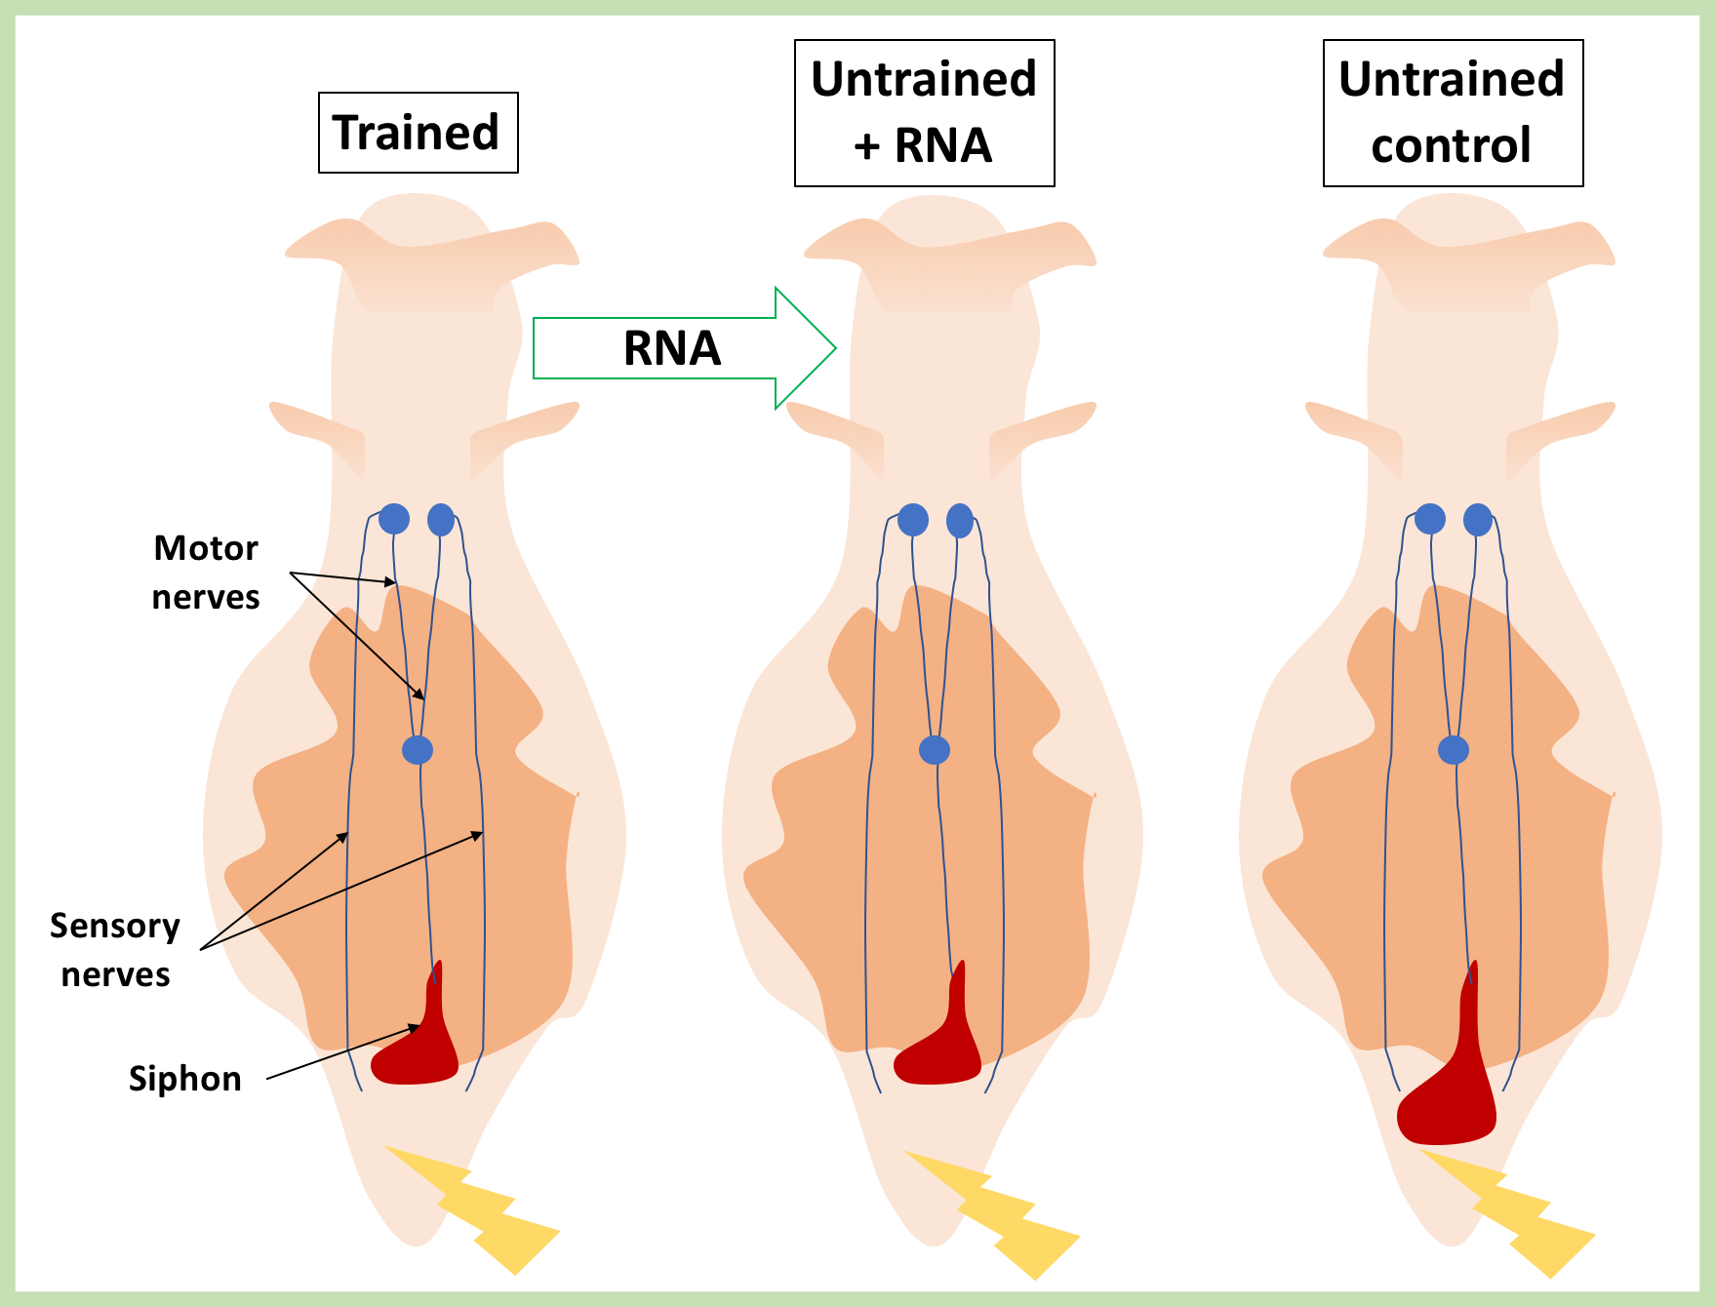
Figure 1: Basic Aplysia anatomy (left). Trained/sensitized animals experienced SWR when given an electric shock. RNA was extracted from trained Aplysia (left) and injected into naïve untrained Aplysia (middle). Control untrained Aplysia were given an injection lacking trained Aplysia RNA. The untrained animals injected with RNA exhibit SWR, whereas the control untrained animals do not.

References Cited:

Bédécarrats, A., Chen, S., Pearce, K., Cai, D., & Glanzman, D. L. (2018). RNA from Trained Aplysia
Can Induce an Epigenetic Engram for Long-Term Sensitization in Untrained
Aplysia. eNeuro, 5(3), ENEURO-0038.

Bird, A. (2002). DNA methylation patterns and epigenetic memory. Genes & development, 16(1),
6-21.

Lynch, M. A. (2004). Long-term potentiation and memory. Physiological reviews, 84(1), 87-136.

Pinsker HM, Hening W, A., Carew TJ, Kandel ER (1973) Long-term sensitization of a defensive
withdrawal reflex in Aplysia . Science 182:1039-1042.

Zovkic IB, Guzman-Karlsson MC, Sweatt JD (2013) Epigenetic regulation of memory formation
and maintenance. Learn Mem 20:61-74.

